Case Report

National Gallery DC

### Tracy’s iPhone [2012-07-15-National-Gallery]

# Table of Contents

Case Report

National Gallery DC

Tracy’s iPhone [2012-07-15-National-Gallery]

Table of Contents

Executive Summary

Equipment and Tools

Details of Tracy’s iPhone

Evidence to Establish Personas

Evidence relating to theft of valuable stamps

Evidence relating to defacement of museum art

Plot Timeline

Conclusion

Appendix A: Correspondence Evidence

Appendix B: WiFi and GPS Location Information

# Executive Summary

On January 21, 2016, Digitech Inc. was called in to assist the National Gallery, Washington D.C. (NGDC) case involving the conspiracy associated with the theft of valuable stamps and defacing of museums are at the NGDC.

* Tracy is a suspect in the aforementioned conspiracy.
* As part of the investigation, Tracy’s iPhone was taken into custody.
* Digitech, Inc. was tasked with investigating evidence relevant to the aforementioned conspiracy.

As described fully in the report, Digitech, Inc. made the following findings.

* Evidence of correspondence between Pat Sumtwelve, Tracy Sumtwelve “King”
* Evidence, including motivation for conspiracy to steal.
* Evidence of knowledge of stamp value
* Evidence that Tracy colluded with Carry to smuggle a tablet into the museum.

### Equipment and Tools

Evidence was gathered from an image of Tracy’s phone using a distribution of Kali linux containing the “autopsy” tool. This tool was used to search for evidence discovery, and to export databases for further analysis with the tool “sqlitebrowser”. Further online tools were used including <https://www.epochconverter.com/>, which was used to convert the timestamps into human readable format, and <https://base64.guru/converter/decode/audio> which was used to decrypt “Crazydave1.mp3”. <https://mobisoftinfotech.com/tools/plot-multiple-points-on-map/>

and <https://www.google.com/maps> were used for interpreting and plotting GPS coordinates. [https://www.google.com](https://www.google.com/) was used to match the stamps on the accused phone with the ones from the insurance documents.

# Details of Tracy’s iPhone

| **Name** | **Findings** | **Location in iPhone image file** |
| --- | --- | --- |
| Model | iPhone1, 2 | /img_tracy-phone-2012-07-15-final.E01/vol/logs/AppleSupport/general.log |
| Host Name | Tracy Sumtwelve’s phone | /img_tracy-phone-2012-07-15-final.E01/vol_vol5/logs/lockdownd.log.1 |
| OS Version | iPhone OS 4.2.1 | /img_tracy-phone-2012-07-15-final.E01/vol/logs/AppleSupport/general.log |
| Install Time | 6/6/2012 12:03:28 -0700 | /img_tracy-phone-2012-07-15-final.E01/vol/logs/AppleSupport/general.log |
| User Email | [tracysumtwelve@gmail.com](mailto:tracysumtwelve@gmail.com), [coralbluetwo@hotmail.com](mailto:coralbluetwo@hotmail.com) | /img_tracy-phone-2012-07-15-final.E01/vol_vol5/mobile/Library/mail/ Envelope Index |
| Phone Number | (703) 340-9661 | /img_tracy-phone-2012-07-15-final.E01/vol_vol5/logs/lockdownd.log.1 |
| Serial Number | 86004482Y7H | /img_tracy-phone-2012-07-15-final.E01/vol/logs/AppleSupport/general.log |
| ICCID | 89014103255195342366 | /img_tracy-phone-2012-07-15-final.E01/vol_vol5/logs/lockdownd.log |
| IMEI | 004999010640000 | /img_tracy-phone-2012-07-15-final.E01/vol_vol5/logs/lockdownd.log |
| MD5 Hash | 34c4888f095dc3241330462923f6fea5 | Image file |
| SHA256 Hash | 71aed05a86a753dec4ef4033ed7f52d6577ccb534ca0d1e83ffd27683e621607 | Image file |

# Evidence to Establish Personas

This section establishes aliases, phone numbers, emails addresses associated with each person, and relationships between each individual.

Tracy “Coral”:

Phone Number: (703) 340-9961

Personal Email: [tracysumtwelve@gmail.com](mailto:tracysumtwelve@gmail.com)

Work Email: [tracy.sumtwelve@nationalgallerydc.org](mailto:tracy.sumtwelve@nationalgallerydc.org)

Alias Email: [coralbluetwo@hotmail.com](mailto:coralbluetwo@hotmail.com)

Relationship: Accused

Pat “Perry”:

Phone Number: (571) 308-3236

Email: [patsumtwelve@gmail.com](mailto:patsumtwelve@gmail.com)

Alias Email: [perrypatsum@yahoo.com](mailto:perrypatsum@yahoo.com)

Relationship: Brother

Terry:

Phone Number: (703) 829-6071

Email: Unknown

Relationship: Daughter

Joe:

Phone Number: Unknown

Email: [joe.sum.twelve@gmail.com](mailto:joe.sum.twelve@gmail.com)

Relationship: Ex-Husband

Carry:

Phone Number: (202) 725-2124

Email: [carrysum2012@yahoo.com](mailto:carrysum2012@yahoo.com)

Relationship: Acquaintance

King:

Phone Number: Unknown

Email: [throne1966@gmail.com](mailto:throne1966@gmail.com)

Relationship: Pat’s acquaintance.

Tracy conspired with Pat with the Alias’ “Coral” and “Perry” respectively. Through the use of email: [coralbluetwo@hotmail.com](mailto:coralbluetwo@hotmail.com) and [perrypatsum@yahoo.com](mailto:perrypatsum@yahoo.com).

# Evidence relating to theft of valuable stamps

This sub-section provides details regarding the evidence found as it relates to the theft of valuable stamps.

The findings of this report illustrate a woman in financial hardship, losing touch with her daughter.

This image of desperation becomes clearer as the accused motivation as we examine the text and email correspondence between her and Pat, Carry, Joe and Terry.

Referring to Evidence *“E7”*  along with *”T5”* and *“T6”* of Appendix A we can see that this desperation has resulted in the accused requesting financial assistance from Joe, as she can no longer afford to pay for Terry’s school fees. The subsequent texts between the accused and her daughter show that If Tracy can no longer pay for Terry’s schooling that she would prefer to live with her father Joe. Referring to *“C362”, “C364”* and *“C370”* of Appendix B would support this theory, as based on the GPS coordinates placing her near different schools. Understanding the motivation for the crime we can now examine the evidence of conspiracy to steal.

Firstly we must establish as fact that [coralbluetwo@hotmail.com](mailto:coralbluetwo@hotmail.com) is in use by Tracy and that [perrypatsum@yahoo.com](mailto:perrypatsum@yahoo.com) is in use by Pat. This can be confirmed by evidence *“E11”* and *“E5”* of Appendix A. Following that we can see evidence of their conspiracy from the discovery of the opportunity in Artifact *“E6”* to the planning of the heist in Artifact *“E10”* and *“E15”* where they can be seen conspiring to steal with known criminal, King; which includes a text document containing a list of items needed to complete the heist:

Screenshot from *“needs.txt”:*

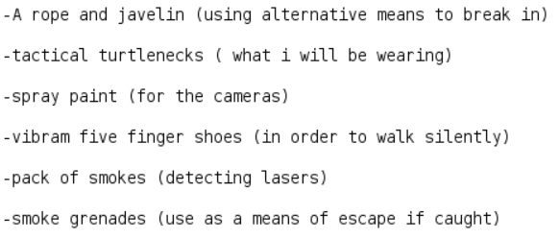

Artifact *“E12”* is an email between Tracy and her alias account Coral, containing the insurance information for the stamps, which Tracy would have used to determine their value:

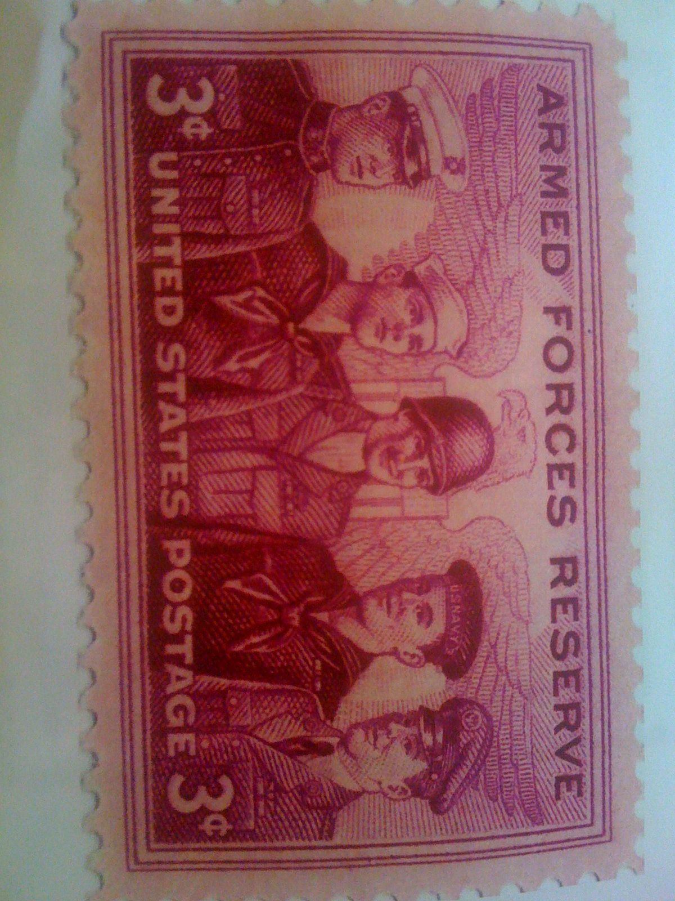

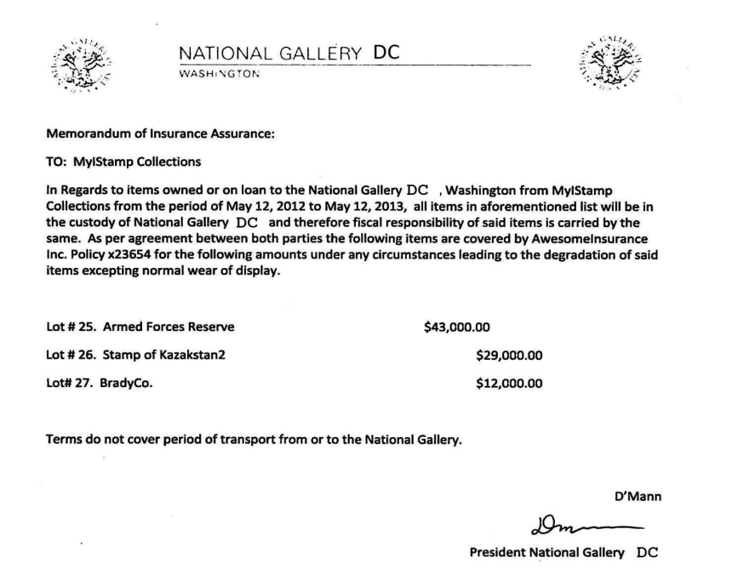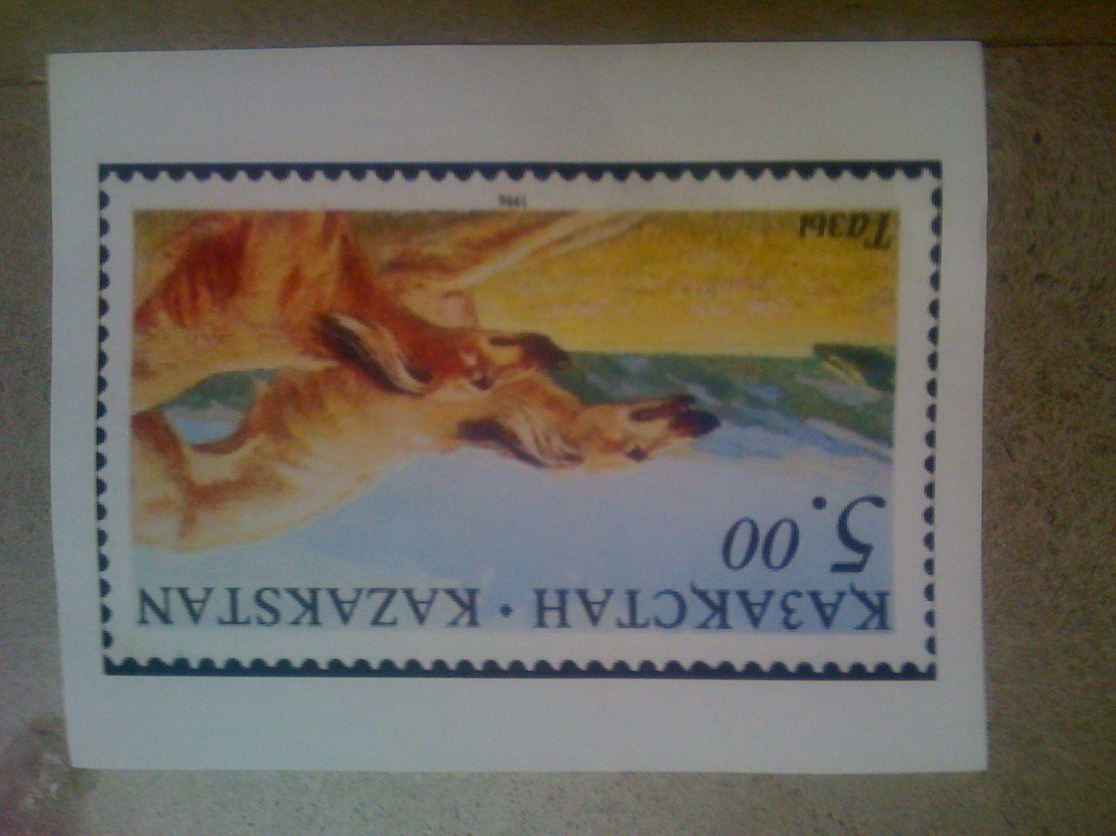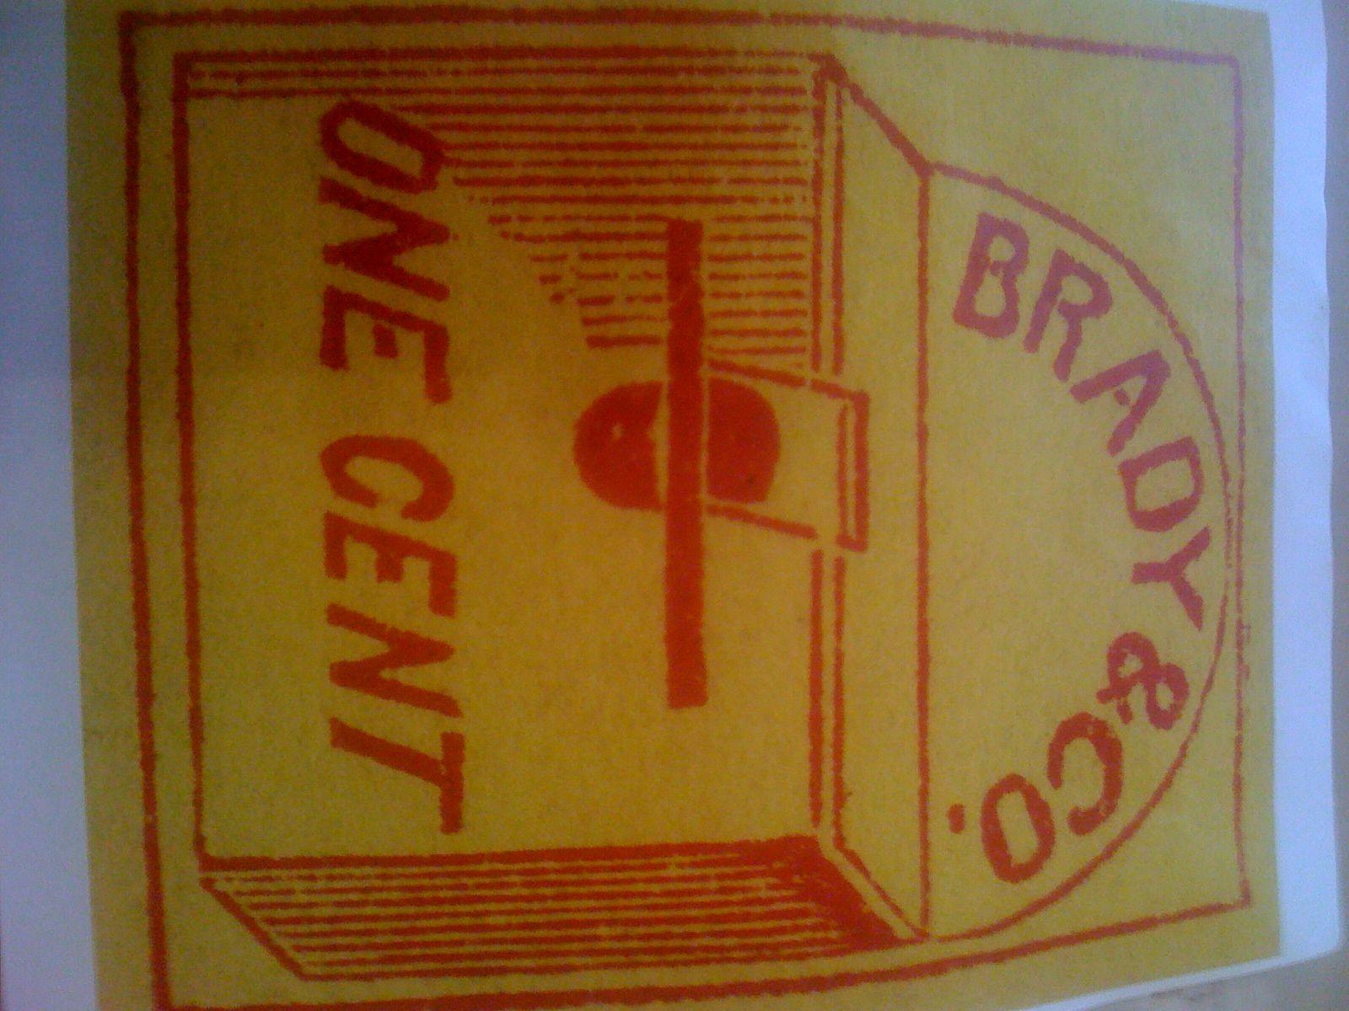

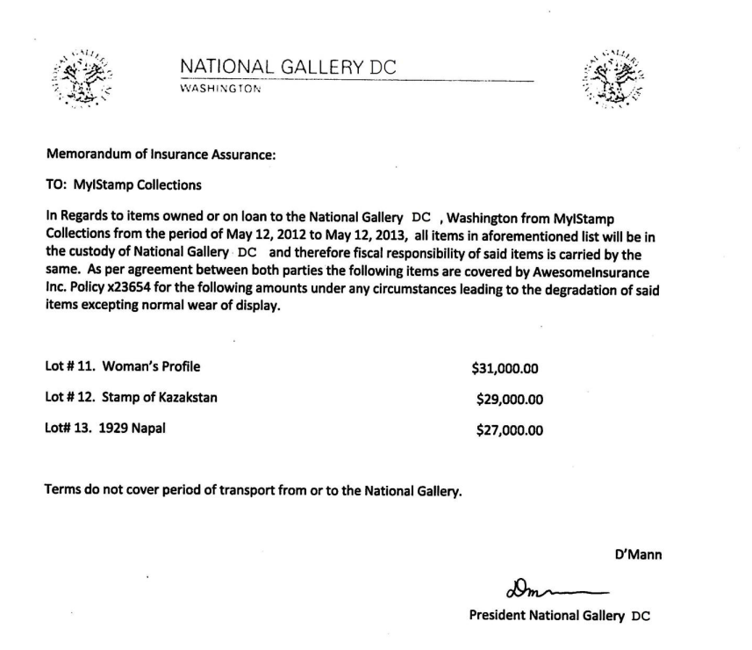

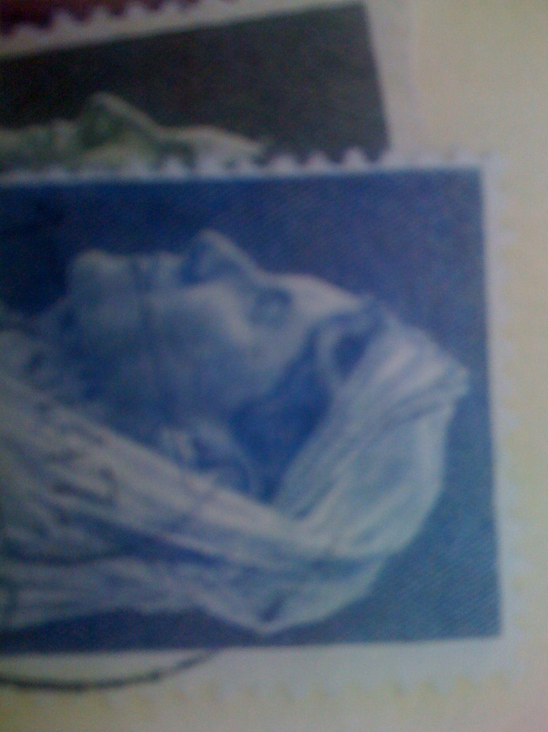







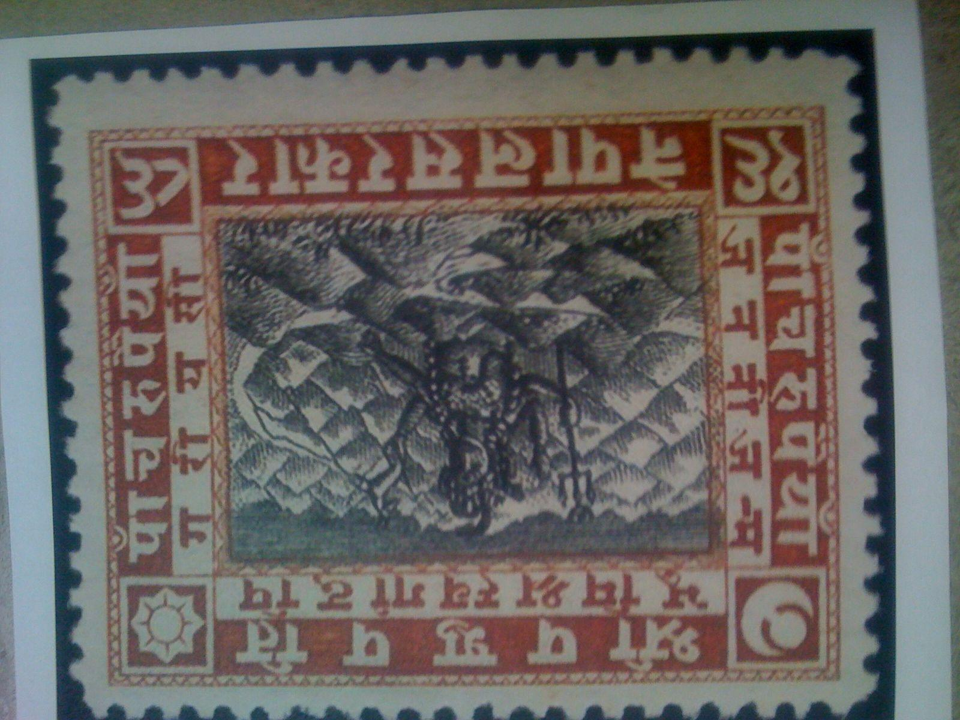



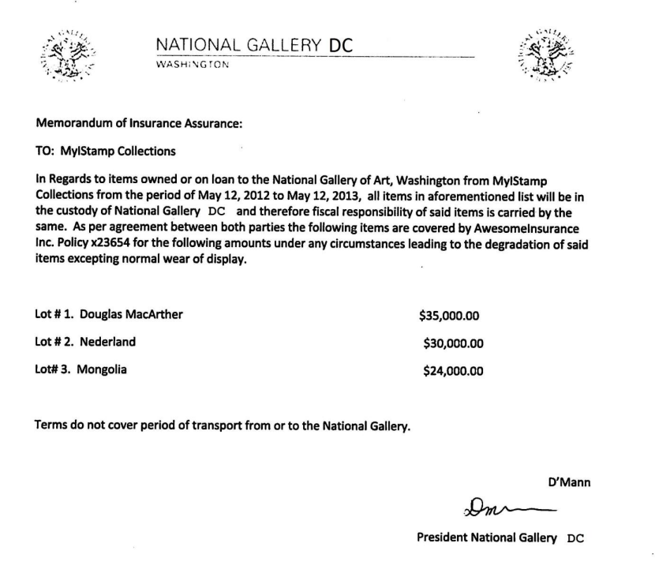

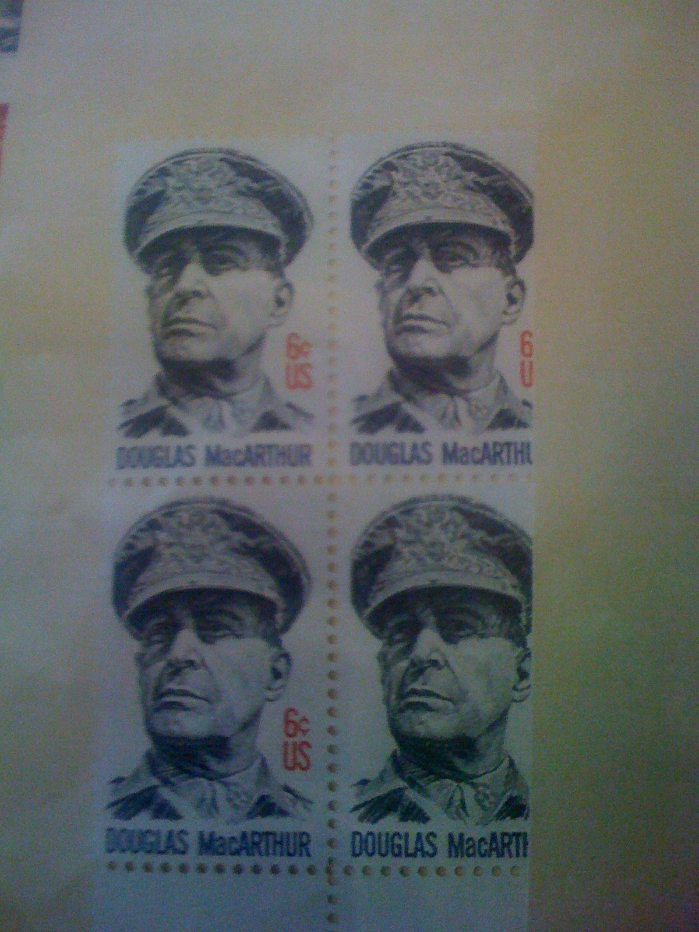



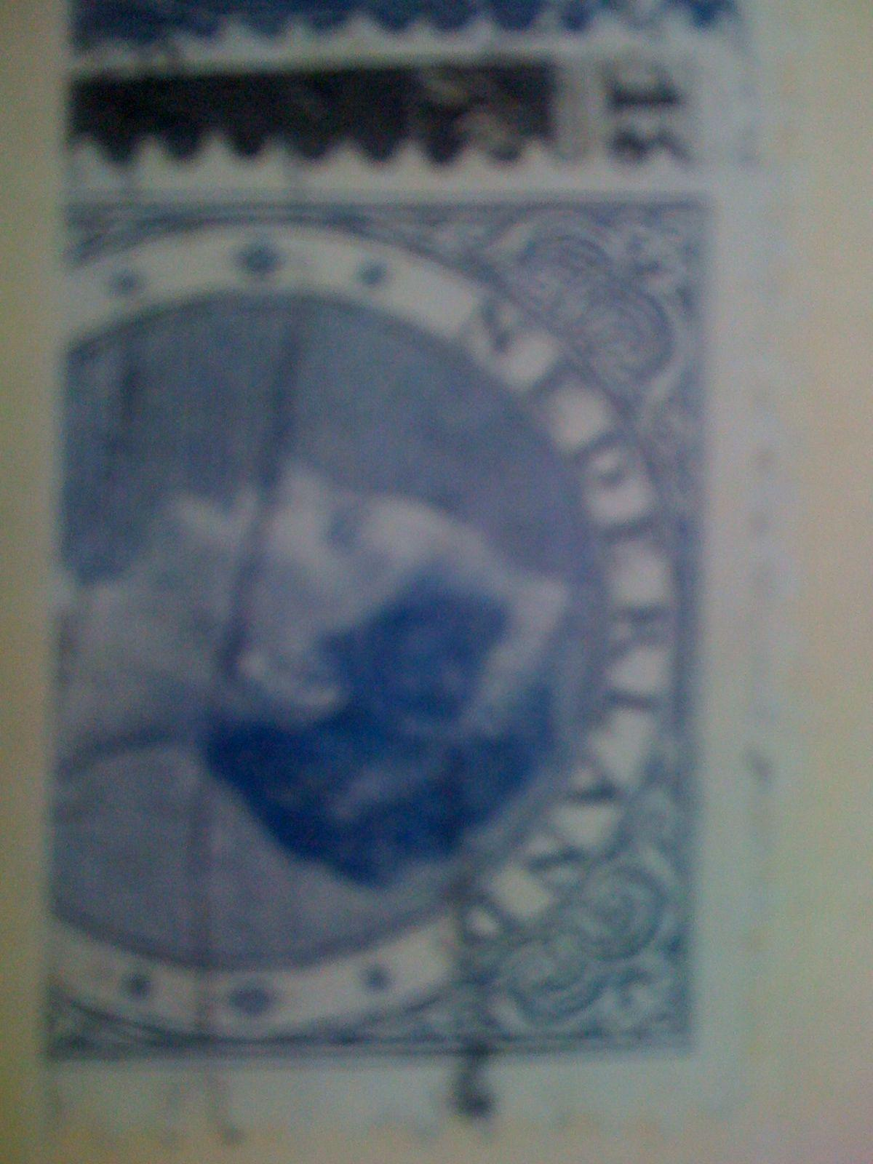





These insurance documents were then cross-referenced with photos found on the accused phone in *“/vol5/mobile/Media/DCIM/100APPLE”* The total value of the 9 stamps according to the insurance information is $260,000.

# Evidence relating to defacement of museum art

This sub-section provides details regarding the evidence found as it relates to the defacement of museum art.

We can prove communication between Tracy and Carry, and the conspiracy for the accused to smuggle the tablet into the museum as per Appendix A artifact *“E14”*, We can also prove that they met with the correspondence between Artifact *“T13”* and *“T14”* of the same Appendix. Per *“E16”* of Appendix A we can also see mention of payment for services, which likely is fulfilled in Artifact T15 - a $1000 payment disguised as a target voucher. However due to the majority of conversation surrounding this deal occuring in person, it is impossible for us to prove anything further without additional seizure of data pertaining to the case.

# Plot Timeline

6/19/2012 20:26:47 - Pat emails Tracy using his alias email “Perry” informing her to do the same.

6/19/2012 21:38:59 - Pat emails Tracy, both now using their alias’, with encoded instructions to install a virtual box for secure communications.

6/29/2012 14:31:36 - Pat accidentally messages Tracy’s official email with his alias, incriminating himself.

7/2/2012 16:13:18 - Pat and Tracy become aware of the potential for making some money via a foreign exhibition.

7/3/2012 13:29:37 - Tracy asks Joe for financial assistance, he declines.

7/3/2012 14:04:32 - Terry says she would rather live with her father if her mother can’t send her to Prufrock.

7/3/2012 14:53:04 - Pat and Tracy become aware that the foreign exhibition is rare stamps, and Pat begins looking into a means to “pull it off”

7/5/2012 18:20:26 - Carry and Tracy make arrangements to meet in person

7/6/2012 15:18:50 - Pat and Tracy have an “important” 244 second phone call

7/6/2012 15:49:31 - Pat and Tracy make contact with King for the first time.

7/6/2012 16:27:16 - Carry and Tracy meet at Bubba’s grill

7/6/2012 19:36:35 - Carry receives a $1000 payment disguised as a target voucher.

7/6/2012 17:59:24 - Pat messages Tracy on her official email with the login details for her alias which she forgot.

7/9/2012 14:44:11 - Tracy emails stamp insurance information from her official account to her alias account, proving she knows their value.

7/9/2012 18:18:47 - Carry asks Tracy to help smuggle her tablet into the museum, to which she agrees

7/10/2012 15:24:57 - an email including Tracy, Pat and King points to their plan to steal from the museum, and includes a text document with a list of tools required for the heist.

7/11/2012 12:49:08 - Tracy smuggles Carry’s tablet into the museum.

7/11/2012 17:06:19 - Carry asks Tracy about security shift change time, and they mention payment for the first time.

7/12/2012 17:06:45 - Tracy texts Carry asking about the flashmob.

# Conclusion

# Evidence found on Tracy’s iPhone indicated the following:

* Tracy communicated under the alias “Coral” [coralbluetwo@hotmail.com](mailto:coralbluetwo@hotmail.com)
* Pat communicated under the alias “Perry” [perrypatsum@yahoo.com](mailto:perrypatsum@yahoo.com)
* Tracy, Pat and King were involved in a conspiracy to steal stamps from the museum, due to take place 2 weeks from 7/10/2012.
* Pat blackmailed King into assisting as he knows King's parole officer.
* Tracy couldn’t afford Terry’s schooling.
* This crime was motivated by financial difficulties.
* Tracy received a payment disguised as a target voucher shortly after her meeting with Carry.
* There are activity trends present in the Wifi and Cell location data taken from Tracy’s phone, however due to inaccurate timestamps it’s impossible to make accurate judgments about Tracy’s location at a given time.
* Tracy’s plan to steal the stamps was calculated.
* Tracy assisting Carry was opportunistic.

# 

# Appendix A: Correspondence Evidence

| Master Timeline of NGDC | | | | |
| --- | --- | --- | --- | --- |
| Artifact # | Timestamp | Header Information | Key Information | Evidence Location |
| T1 | 6/12/2012  21:25:04 | From (703) 340-9961Tracy  To (571) 308-3236 Pat | What are you up to this weekend? | /vol5/mobile/Library/SMS/sms.db |
| T2 | 6/13/2012  17:30:28 | From (703) 829-6071 Terry  To (703) 340-9961Tracy | I'm going out with dad after school for pizza! Thought I'd let you know if you planned to cook.  T | /vol5/mobile/Library/SMS/sms.db |
| T3 | 6/13/2012  18:30:38 | From (571) 308-3236 Pat  To (703) 340-9961Tracy | I don't have any big plans. How about you? | /vol5/mobile/Library/SMS/sms.db |
| T4 | 6/13/2012  18:33:46 | From (703) 340-9961Tracy  To (703) 829-6071 Terry | Ok, sounds good. | /vol5/mobile/Library/SMS/sms.db |
| E1 | 6/19/2012 20:06:33 | From [patsumtwelve@gmail.com](mailto:patsumtwelve@gmail.com)  To [tracysumtwelve@gmail.com](mailto:tracysumtwelve@gmail.com)  Subject: Paris Speak and answer | Tracy, Je considérais votre proposition. Ma réponse est oui! Vous avez dit que vous avez un alias. Envoyez-moi l'adresse e-mail, et je vais vous fournir des instructions supplémentaires. caresse  *Evidence of Tracy having an alias email address. | /vol5/mobile/Library/Mail/Protected Index |
| E2 | 6/19/2012  20:26:47 | From [perrypatsum@yahoo.com](mailto:perrypatsum@yahoo.com)  To [tracysumtwelve@gmail.com](mailto:tracysumtwelve@gmail.com)  Subject: Look me up sometime | Tracy, Talked to your brother about an email. You should have your friend, Alias, send me an email. Thanks Perry, | /vol5/mobile/Library/Mail/Protected Index |
| E3 | 6/19/2012  21:38:59 | From [perrypatsum@yahoo.com](mailto:perrypatsum@yahoo.com)  To [coralbluetwo@hotmail.com](mailto:coralbluetwo@hotmail.com)  Subject: CrazyDave by the VMs | Just got your email. That took longer than expected! Oh well! You've got to check out this new song by the VMs. I love the base. Tell me what you think!  *Contains base64 encoded mp3.  “Crazydave1.mp3”, decoded it contains instructions on how to install a virtual box for secure communications. | /vol5/mobile/Library/Mail/POP-coralbluetwo@hotmail.com/pop3.live.com/INBOX.mbox/Messages |
| E4 | 6/21/2012  17:43:15 | From [perrypatsum@yahoo.com](mailto:perrypatsum@yahoo.com)  To [coralbluetwo@hotmail.com](mailto:coralbluetwo@hotmail.com)  Subject: Re: CrazyDave by the VMs | Yes Perry, that song was great. It really ‘set me up’ for a good listen | /vol5/mobile/Library/Mail/POP-coralbluetwo@hotmail.com/pop3.live.com/INBOX.mbox/Messages |
| E5 | 6/29/2012  14:31:36 | From [perrypatsum@yahoo.com](mailto:perrypatsum@yahoo.com)  To [tracysumtwelve@gmail.com](mailto:tracysumtwelve@gmail.com)  Subject: hey sis | Hey sis,How have things been working at home? Did Terry sort out those problems she was having in her literature class? I’m sorry I haven't been able to check in with you guys more often... I have been busy trying to sort some things with your friend Coral. We should all go out for dinner as friends some time! Check in with her. Pat  *Evidence links Pat to his alias email “Perry”, referring to Tracy as his sister and signing off with his real name. | /vol5/mobile/Library/Mail/Protected Index |
| E6 | 7/2/2012  16:13:18 | From [perrypatsum@yahoo.com](mailto:perrypatsum@yahoo.com)  To [coralbluetwo@hotmail.com](mailto:coralbluetwo@hotmail.com)  Subject: Re: Some good news | Awesome. Hopefully this turns out to be our lucky break.  Perry  —-------------------------------------------  Perry,  I think i may have come across something interesting. Everybody around the office seems to be buzzed about a foreign exhibit that is supposed to be coming over. There hasn’t been any official release in writing but we have been going through quite the ordeal with all this paperwork. From what i can tell, this exhibit has to be a big deal. I’ll let you know if I found anything else out.  Coral | /vol5/mobile/Library/Mail/POP-coralbluetwo@hotmail.com/pop3.live.com/INBOX.mbox/Messages |
| E7 | 7/3/2012  13:29:37 | From [joe.sum.twelve@gmail.com](mailto:joe.sum.twelve@gmail.com)  To [tracysumtwelve@gmail.com](mailto:tracysumtwelve@gmail.com) | Sorry Tracy. I'm not going to be paying for Terry's school if shes not living with me. I hope things take an upturn for you. Joe On Mon, Jul 2, 2012 at 4:06 PM, Tracy Sumtwelve <tracysumtwelve@gmail.com> wrote: Joe, Sorry to bother you, but I have a serious question about Terry and her school. Her tuition is getting a bit too much for me right now and I could use a little help. I hate to impose on you for this, but is there any way you would be willing to help me out with her tuition this year? Please get back to me, Tracy  *Evidence of financial motivation | /vol5/mobile/Library/Mail/Protected Index |
| T5 | 7/3/2012  13:41:51 | From (703) 340-9961Tracy  To (703) 829-6071 Terry | Hey honey. I'm not sure if we can afford Prufrock anymore... What do you think about maybe switching to someplace else?  *Evidence of financial motivation | /vol5/mobile/Library/SMS/sms.db |
| T6 | 7/3/2012  14:04:32 | From (703) 829-6071 Terry  To (703) 340-9961Tracy | moving schools at this point would be the worst! i would rather live with dad and stay at prufrock then change schools :( | /vol5/mobile/Library/SMS/sms.db |
| E8 | 7/3/2012  14:53:04 | From [perrypatsum@yahoo.com](mailto:perrypatsum@yahoo.com)  To [coralbluetwo@hotmail.com](mailto:coralbluetwo@hotmail.com)  Subject: Re: Some good news | That may just be exactly what we need. Try to collect as much information on the exhibit as you can, the more information… the better. In the meantime, I will try to look into our options for actually pulling something like this off.  —-------------------------------------------  I was told that we are supposed to be receiving a rare collection of stamps. That would explain why the shipping information looked a bit out of the ordinary to me. I’m not certain of the specifics for the stamps, but they seem to be very highly valued by somebody. Maybe this is our ticket.  *Evidence of the target of the heist | /vol5/mobile/Library/Mail/POP-coralbluetwo@hotmail.com/pop3.live.com/INBOX.mbox/Messages |
| E9 | 7/5/2012  15:51:31 | From [carrysum2012@yahoo.com](mailto:carrysum2012@yahoo.com)  To [tracysumtwelve@gmail.com](mailto:tracysumtwelve@gmail.com)  Subject: Long time no see… | Hi, I saw on facebook that you were having a hard time lately, and i realized that we haven't spoken face to face in quite a while. I was really hoping that we could get together and have lunch. Does this Friday sound good? Let me know. -Carry | /vol5/mobile/Library/Mail/Protected Index |
| T7 | 7/5/2012  18:18:23 | From (703) 340-9961Tracy  To (202) 725-2124 Carry | Sounds good let's shoot for one àt Bubba s grill | /vol5/mobile/Library/SMS/sms.db |
| T8 | 7/5/2012  18:20:26 | From (202) 725-2124 Carry  To (703) 340-9961Tracy | Okay that sounds great. See you there | /vol5/mobile/Library/SMS/sms.db |
| T9 | 7/6/2012  15:02:19 | From (703) 340-9961Tracy  To (571) 308-3236 Pat | Hey can you give me a call | /vol5/mobile/Library/SMS/sms.db |
| T10 | 7/6/2012  15:08:37 | From (571) 308-3236 Pat  To (703) 340-9961Tracy | Sis I'm really busy can we can do this later | /vol5/mobile/Library/SMS/sms.db |
| T11 | 7/6/2012  15:11:54 | From (703) 340-9961Tracy  To (571) 308-3236 Pat | No pat this is important I need you to call me soon | /vol5/mobile/Library/SMS/sms.db |
| T12 | 7/6/2012  15:13:31 | From (571) 308-3236 Pat  To (703) 340-9961Tracy | Ok ok I'll call in 5 | /vol5/mobile/Library/SMS/sms.db |
| C1 | 7/6/2012  15:18:50 | From (571) 308-3236 Pat  To (703) 340-9961Tracy | 244 second call | /vol5/mobile/Library/CallHistory/call_history.db |
| E10 | 7/6/2012  15:49:31 | From [patsumtwelve@gmail.com](mailto:patsumtwelve@gmail.com)  To [throne1996@hotmail.com](mailto:throne1996@hotmail.com)  CC: [coralbluetwo@hotmail.com](mailto:coralbluetwo@hotmail.com)  Subject: can’t pass up | hey sis i know a guy...he’s known as king On Tue, Jul 3, 2012 at 9:34 AM, Tracy Sumtwelve <tracysumtwelve@gmail.com> wrote: I just talked to Coral, she sounded ecstatic. She mentioned she just got some great news about her job. You should catch up with her. Tracy | /vol5/mobile/Library/Mail/POP-coralbluetwo@hotmail.com/pop3.live.com/INBOX.mbox/Messages |
| T13 | 7/6/2012  16:27:16 | From (703) 340-9961Tracy  To (202) 725-2124 Carry | I have a table inside | /vol5/mobile/Library/SMS/sms.db |
| T14 | 7/6/2012  16:27:50 | From (202) 725-2124 Carry  To (703) 340-9961Tracy | Okay brt | /vol5/mobile/Library/SMS/sms.db |
| T15 | 7/6/2012  19:36:35 | From (206) 910-0932  To (703) 340-9961 Tracy | Congratulations, your entry in last months drawing won you a free $1,000 Target giftcard! Enter “703” at [www.target.com.trdt.biz](http://www.target.com.trdt.biz) to tell us where to ship it  *Evidence of a potential payment | /vol5/mobile/Library/SMS/sms.db |
| E11 | 7/6/2012  17:59:24 | From [perrypatsum@yahoo.com](mailto:perrypatsum@yahoo.com)  To [tracysumtwelve@gmail.com](mailto:tracysumtwelve@gmail.com)  Subject: Re: Good News | Hey sis here is the login info for the other account we talked about - AGAIN coralblue@hotmail.com PW: legalBee On Fri, Jul 6, 2012 at 11:42 AM, Tracy TeeSumTwelve <tracysumtwelve@gmail.com> wrote: Oh cool, we should hang out sometime. On Fri, Jul 6, 2012 at 11:27 AM, Pat TeeSumTwelve <patsumtwelve@gmail.com> wrote: hey sis i know a guy...he’s known as king On Tue, Jul 3, 2012 at 9:34 AM, Tracy Sumtwelve <tracysumtwelve@gmail.com> wrote: I just talked to Coral, she sounded ecstatic. She mentioned she just got some great news about her job. You should catch up with her. Tracy  *Evidence linking Tracy to her email alias “Coral”, by proving she had access to the account. | /vol5/mobile/Library/Mail/POP-coralbluetwo@hotmail.com/pop3.live.com/INBOX.mbox/Messages |
| E12 | 7/9/2012  14:44:11 | From [tracysumtwelve@gmail.com](mailto:tracysumtwelve@gmail.com)  To [coralbluetwo@hotmail.com](mailto:coralbluetwo@hotmail.com)  Subject: things | *“Documents.zip”  Containing insurance information for the stamps, illustrating their value. | /vol5/mobile/Library/Mail/POP-coralbluetwo@hotmail.com/pop3.live.com/INBOX.mbox/Messages |
| E13 | 7/9/2012  18:18:47 | From [carrysum2012@yahoo.com](mailto:carrysum2012@yahoo.com)  To [tracysumtwelve@gmail.com](mailto:tracysumtwelve@gmail.com)  Subject: Re: Long time no see… | Hey I was wondering if there was any way you could help me get my tablet into the gallery. I know security isn't to keen on computers and the like in the gallery, but maybe you could pull some strings and get it in for me? I can make it worth your while :) But really I would happy to get lunch again or something else for your help. I want to get some pictures for my flash mob event I told you about. Let me know. ------------------------------ On Fri, Jul 6, 2012 10:55 AM PDT Tracy Sumtwelve wrote: Hey Carry, Just wanted to say thanks for lunch. I had a great time and it was good catching up with you. We should d | /vol5/mobile/Library/Mail/Protected Index |
| E14 | 7/10/2012  13:48:40 | From [carrysum2012@yahoo.com](mailto:carrysum2012@yahoo.com)  To [tracysumtwelve@gmail.com](mailto:tracysumtwelve@gmail.com)  Subject: Re: Long time no see… | Awesome this will be a big help. Can i come in tommorrow, around 9? ------------------------------ On Tue, Jul 10, 2012 6:29 AM PDT Tracy Sumtwelve wrote: Hey, I can definitely help get your tablet in. Our security guards can be pretty ridiculous sometimes! When would you want to get in and take a look around? | /vol5/mobile/Library/Mail/Protected Index |
| E15 | 7/10/2012  15:24:57 | From [patsumtwelve@gmail.com](mailto:patsumtwelve@gmail.com)  To [throne1996@hotmail.com](mailto:throne1996@hotmail.com)  CC: [coralbluetwo@hotmail.com](mailto:coralbluetwo@hotmail.com)  Subject: Fwd: can’t pass up | King,  Long time no see...I have a juicy proposition for you. Two weeks from now, me and my associates are planning a heist at the national gallery. Although, we need a helping hand. I know that you are on parole right now and are probably hesitant to participate. Me and your parole officer go years back. He is a very strict fellow. If he were to find out that you were dealing drugs and shooting dope in your veins every night, i feel he wouldn’t be too happy. It’s very easy for a person to phone the feds an  anonymous tip that you are on drugs and the location of your stash. All they have to do is give you a drug test and since you're on parole, the feds don’t need a search warrant. Well hit me up. You know where to find  me.  * Evidence in the form of a list of tools “needs.txt”, along with the proof of conspiracy. | /vol5/mobile/Library/Mail/POP-coralbluetwo@hotmail.com/pop3.live.com/INBOX.mbox/Messages |
| T16 | 7/10/2012  15:26:19 | From (571) 308-3236 Pat  To (703) 340-9961Tracy | hey sis yo friend coral got a email the attachment needs to be changed to pdf let her know | /vol5/mobile/Library/SMS/sms.db |
| T17 | 7/10/2012  15:58:04 | From (703) 340-9961Tracy  To (571) 308-3236 Pat | Sure thing I'll get on it | /vol5/mobile/Library/SMS/sms.db |
| T18 | 7/10/2012  17:18:38 | From (703) 340-9961Tracy  To (703) 829-6071 Terry | Going to lunch. You want to go????! | /vol5/mobile/Library/SMS/sms.db |
| T19 | 7/10/2012  18:19:24 | From (703) 340-9961Tracy  To (703) 829-6071 Terry | Back at work | /vol5/mobile/Library/SMS/sms.db |
| T20 | 7/10/2012  18:58:24 | From (703) 829-6071 Terry  To (703) 340-9961Tracy | I'm busy. Maybe this weekend if dad isn't busy | /vol5/mobile/Library/SMS/sms.db |
| T21 | 7/11/2012  12:41:45 | From (202) 725-2124 Carry  To (703) 340-9961Tracy | I'm almost there, where should I meet you? | /vol5/mobile/Library/SMS/sms.db |
| T22 | 7/11/2012  12:49:08 | From (703) 340-9961Tracy  To (202) 725-2124 Carry | Just meet me out front, I'll take the tablet in. | /vol5/mobile/Library/SMS/sms.db |
| E16 | 7/11/2012  17:06:19 | From [carrysum2012@yahoo.com](mailto:carrysum2012@yahoo.com)  To [tracysumtwelve@gmail.com](mailto:tracysumtwelve@gmail.com)  Subject: Re: Long time no see… | Don't. Worry so much. It willbe gun Tracy TeeSumTwelve <tracysumtwelve@gmail.com> wrote: Okay carrie I'm going to send this but you need to make sure no one else sees it okay I could get in a bunch of trouble. I want to help you and I could really use some extra cash too but please please be careful. On Wed, Jul 11, 2012 at 2:53 PM, Carry Sumttwentytwelve < carrysum2012@yahoo.com> wrote: Hey so i'm putting together this event we talked about and i want to make it as painless as possible. I know that your security folk sometimes get a little out of sorts. Is there a good time or maybe you could just let me know when the shift changes so you dont have to know when i am going to do this. | /vol5/mobile/Library/Mail/Protected Index |
| T23 | 7/12/2012  17:06:45 | From (703) 340-9961Tracy  To (202) 725-2124 Carry | How's the flashmob going | /vol5/mobile/Library/SMS/sms.db |
| E17 | 7/12/2012  18:03:51 | From [carrysum2012@yahoo.com](mailto:carrysum2012@yahoo.com)  To [tracysumtwelve@gmail.com](mailto:tracysumtwelve@gmail.com)  Subject: Re: Long time no see… | What do you mean by that? | /vol5/mobile/Library/Mail/Protected Index |
| T23 | 7/13/2012  01:02:10 | From (703) 340-9961Tracy  To (202) 725-2124 Carry | I really want to go to Dad's this weekend. He said he'll take me shopping for school | /vol5/mobile/Library/SMS/sms.db |

### 

# Appendix B: WiFi and GPS Location Information

| Location Information | | | | |
| --- | --- | --- | --- | --- |
| Artifact # | Timestamp | Latitude, Longitude | Body | Map Screenshot |
| C362 | 10 July 2012 16:44:59 | 38.89484888, -77.10822451 | 4009 20th St N, Arlington, VA 22207, USA  *Near new school |  |
| C364 | 10 July 2012 16:44:59 | 38.78245943, -77.16456192 | 6429 Deepford St, Springfield, VA 22150, USA  *Near new school |  |
| C370 | 10 July 2012 16:44:59 | 38.86264371, -77.20756644 | 7521 Jaguar Trail, Falls Church, VA 22042, USA  *Near new school |  |
| C371 | 10 July 2012 16:44:59 | 38.89753884, -77.01965939 | 600 5th St NW, Washington, DC 20001, USA  *Near museum |  |
| C373 | 10 July 2012 16:44:59 | 38.91248232, -77.04351663 | 1900 R St NW, Washington, DC 20009, USA  *Near museum |  |

Wifi location data: Cell location data:

